**Activity 26**

**NAME : M.Varshini COURSE : Mobile Computing Reg No : 192421293 COURSE CODE: ITA0302**

26. Design wireframes for a mobile app showcasing data replication techniques. Use Figma to demonstrate the synchronization process.

**Aim:**

ToDesign a mobile app showcasing data replication techniques using figma

**Procedure:**

1. Open Figma
2. Create a new file
3. Select the Frames
4. Design Visual Elements
5. Make it Interactive
6. Add icons on the Frame
7. Incorporate Multimedia
8. Storyboard Animation
9. Review and edit the Prototype
10. Save and Share

**Design:**

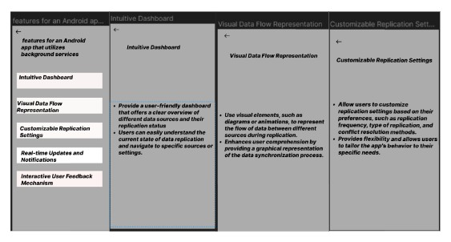

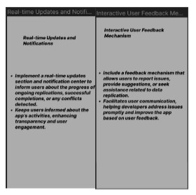

**Prototype:**

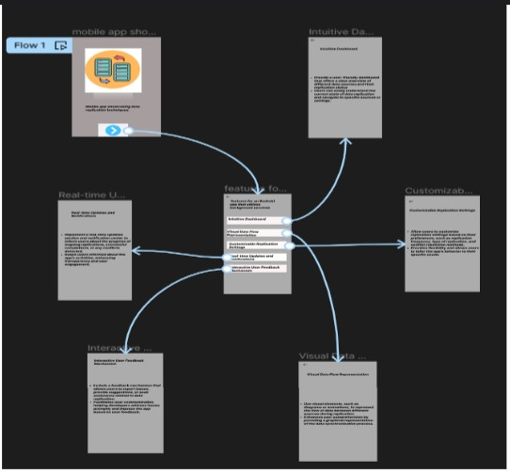

**Result:**

Hence a mobile app showcasing data replication techniques using figma have been created successfully